Escaping Reality

**GAME DESIGN DOCUMENT**

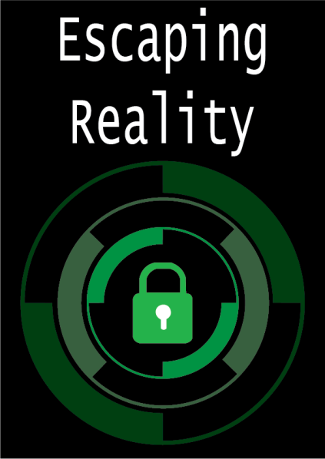

# Contents

Game Overview 3

High Concept 3

Unique Selling Points 3

Platform Minimum Requirements 4

Competence Titles 4

Synopsis 5

Game Objectives 5

Game Rules 5

Game Structure 5

Gameplay 7

Game Controls 7

Game Camera 8

HUD 9

Player 10

Player Characters 10

Player Metrics 10

Puzzles 11

Puzzle 1 11

References 11

Puzzle 2 12

References 13

Puzzle 3 14

References 16

Theme 18

Art Style 18

Setting 18

Animation20

Lightning and Post Processing 21

Level Design 25

Audio 26

MVP (Minimum Viable Product) 27

Wishlist 27

PRODUCER

Temasek Polytechnic

PRODUCTION MANAGER

Temasek Polytechnic

PRODUCTION COORDINATOR

Sean Lim

GAME DESIGNERS

Stanley Lu Liang Yu

Ong Jian Qin

SYSTEMS/IT COORDINATOR

Ryan Oh Tze Xuan

PROGRAMMERS

Ryan Oh Tze Xuan

TECHNICAL ARTISTS

Ong Jian Qin

AUDIO ENGINEERS

Stanley Lu Liang Yu

Written By

Stanley Lu Liang Yu

Ryan Oh Tze Xuan

# Game Overview

Title: Escaping Reality

Platform: VR

Genre: VR escape room

Number of player: Single-player

Target: Casual gamer (aged from 12 - 40)

Release date: September 2022

Publisher: Unity Technologies

Escaping Reality is a first-person VR escape room game where the Player is a Teen (boy or girl) who is locked inside a room, unable to leave.

Now the Player must solve puzzles to escape the room. They may pick up items from the ground and utilize them to help solve the puzzles. When all puzzles are solved, the door can be opened, and the player will have won the game.

# High Concept

Escaping Reality sets the Player in an apartment room where he/she needs to find the right puzzles to solve. Puzzles link from one to another, find the first puzzle and hints are given. Solve them quickly as you do not want to be stuck in your room forever! Use the VR hands to interact with puzzles, the hands can pick up, touch and communicate with the environment. Keep at it until you find a key to free yourself.

# Unique Selling Points

* Stunning Graphics
* Unique puzzles
* Calming ambience

# Platform Minimum Requirements

##### **PC**

**OS**: Windows 10/11

##### **VR**

**Model**: Oculus Rift S

# Competence Titles

Escape Room game by Temasek Polytechnic to promote Immersive Media & Game Development (IGD).

# Synopsis

In a bad dream, your room has been locked. You are the sleepy student who accidentally locked themselves in a room — there is no escape, you must find your own way out!

# Game Objectives

The objective of the game is to find the key to escape the room.

# Game Rules

The game level is a closed environment set in a Teen’s room where the Player is trapped. The Player can move around and interact with objects. In this level, there are 3 different puzzles. Each Puzzle is unique and links to the other. The Player wins by solving all the puzzles. After solving all the puzzles, the Player will find a key to open the door and leave the room.

# Game Structure

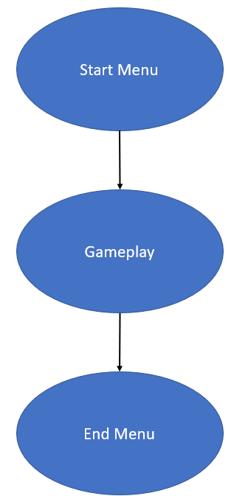

# Gameplay

## Game Controls

The game will utilise most of the buttons found on the Oculus touch controllers.

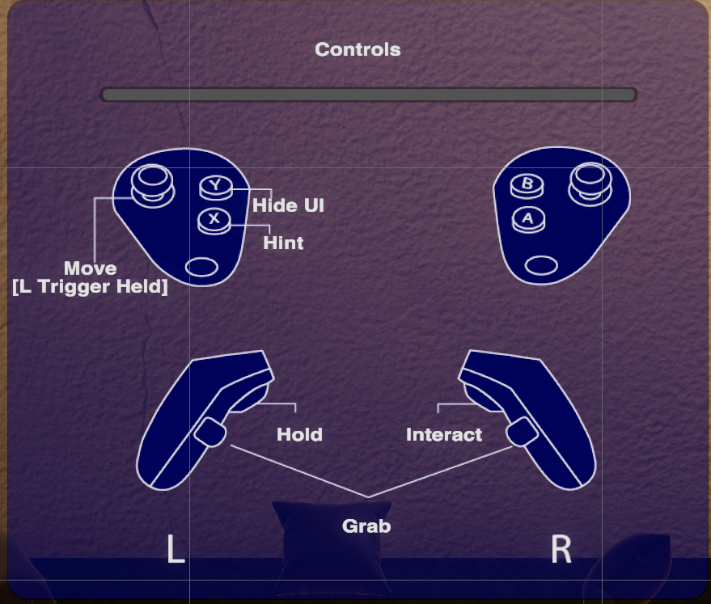

Firstly, the movement uses the left trigger held down and the thumbstick to move. UI and interaction are also shown above on how to use them.

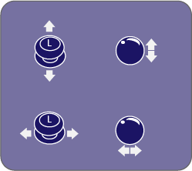

Starting with the ball puzzle, the player will use left thumbstick to move the ball.



Secondly, in the grid puzzle, the player will use the right controller to aim and select their choice of grid element, using the gyroscopic movement to select the element they have chosen. Next, the player will use the right controller’s index finger trigger to select the element.

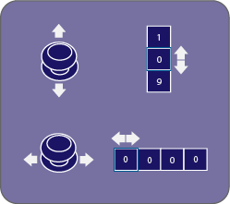

Lastly, in the lock puzzle, the hand trigger will be used to grab onto the lock. When the player grabs onto the lock, UI indicators will show the player that they can use the thumb stick on the hand holding the lock to rotate the dials on the lock by tilting it up and down. The player is also able to select between the different dials by tilting the corresponding thumbstick left and right.

## Game Camera

When the game starts, the camera will track the player's head rotation. Below shows roughly how wide and how high the player can see. As there are two eyes both with slightly different field of view (FOV) the player can see a wide distance. As for the how is based on the player height, if the player is too tall, the player may have to look down and pick up certain objects Otherwise, player can rotate around and look up at the ceiling or the floor.

Horizontal Camera View:

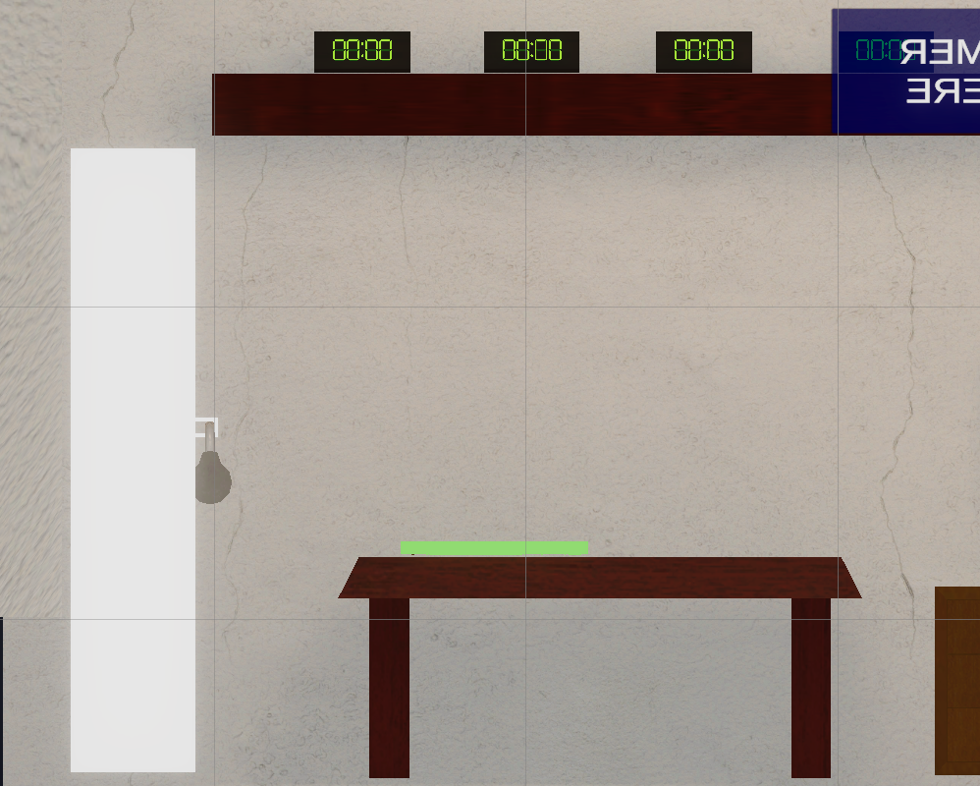

Vertical Camera View:

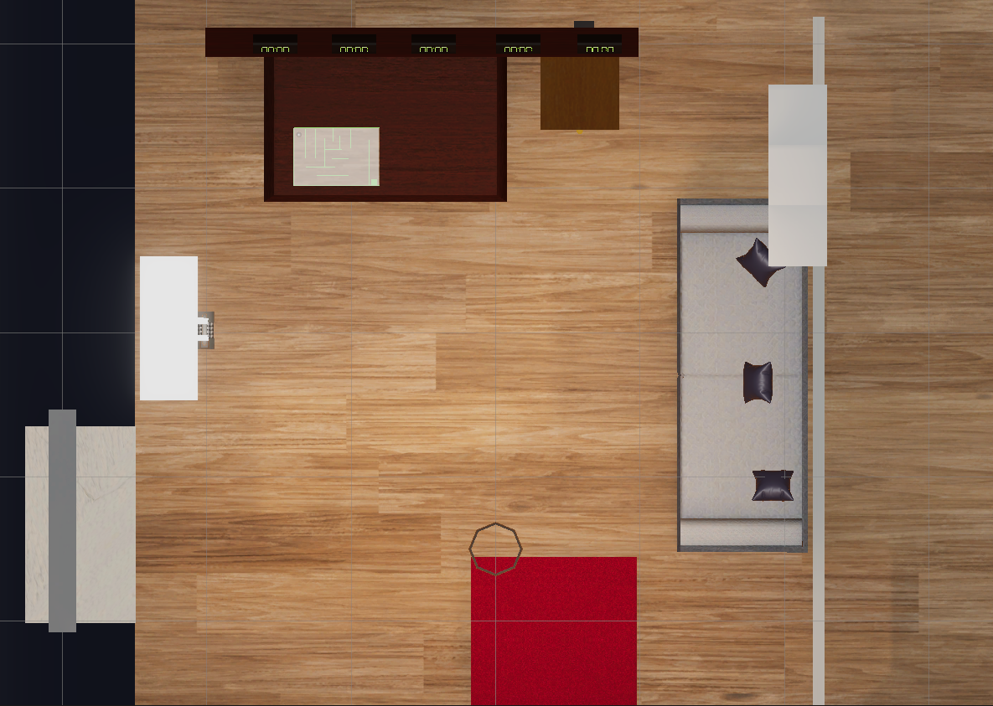

## HUD

##### There will be minimal UI elements in the game except to communicate crucial information so as to preserve the immersion of the player. Such crucial information includes short tutorials/indicators for certain puzzles such as the lock puzzle and ball puzzle. Otherwise, UI elements will be kept to a minimum. Thus, text is communicated through the left controller.

##### 

# Player

## Player Character

## The game will be played in first person. Therefore, the player character will consist of the camera and hands which will replace the controllers and provide a representation of the player’s physical hands in the virtual space. The hands will be animated in such a way that they will react as and when the buttons are pressed, for example they will close into a grabbing motion when the hand triggers are pressed.

## Player Metrics

## There is a timer to keep track of how long the player used to complete the game which will be shown in the end game screen.

# Puzzles

# Game puzzles are to be completed in order.

# 

## Puzzle 1: Ball Puzzle

A ball maze is presented in front of you. The player is tasked to interact with the ball and move it to the other end of the maze.

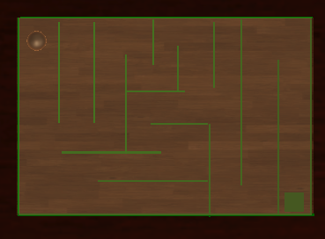

The ball puzzle consists of a ball and a maze.The player will be able to control the ball using the thumb stick of the corresponding controller. The winning condition for the ball puzzle is for the player to control the ball to get to the other side of the maze.To complete the puzzle, move the ball to the other end of the maze. The player will use left thumbstick to move the ball. The HUD will also say,”Move the ball to the other end”.

Upon completion, the game will provide the player with a battery that will be required to complete the following puzzle. The HUD will change to “Charge the clocks”.

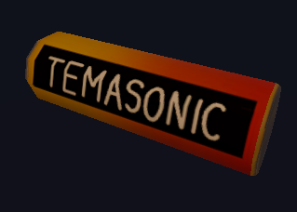

## References

The maze can be referenced to many labyrinth puzzles.

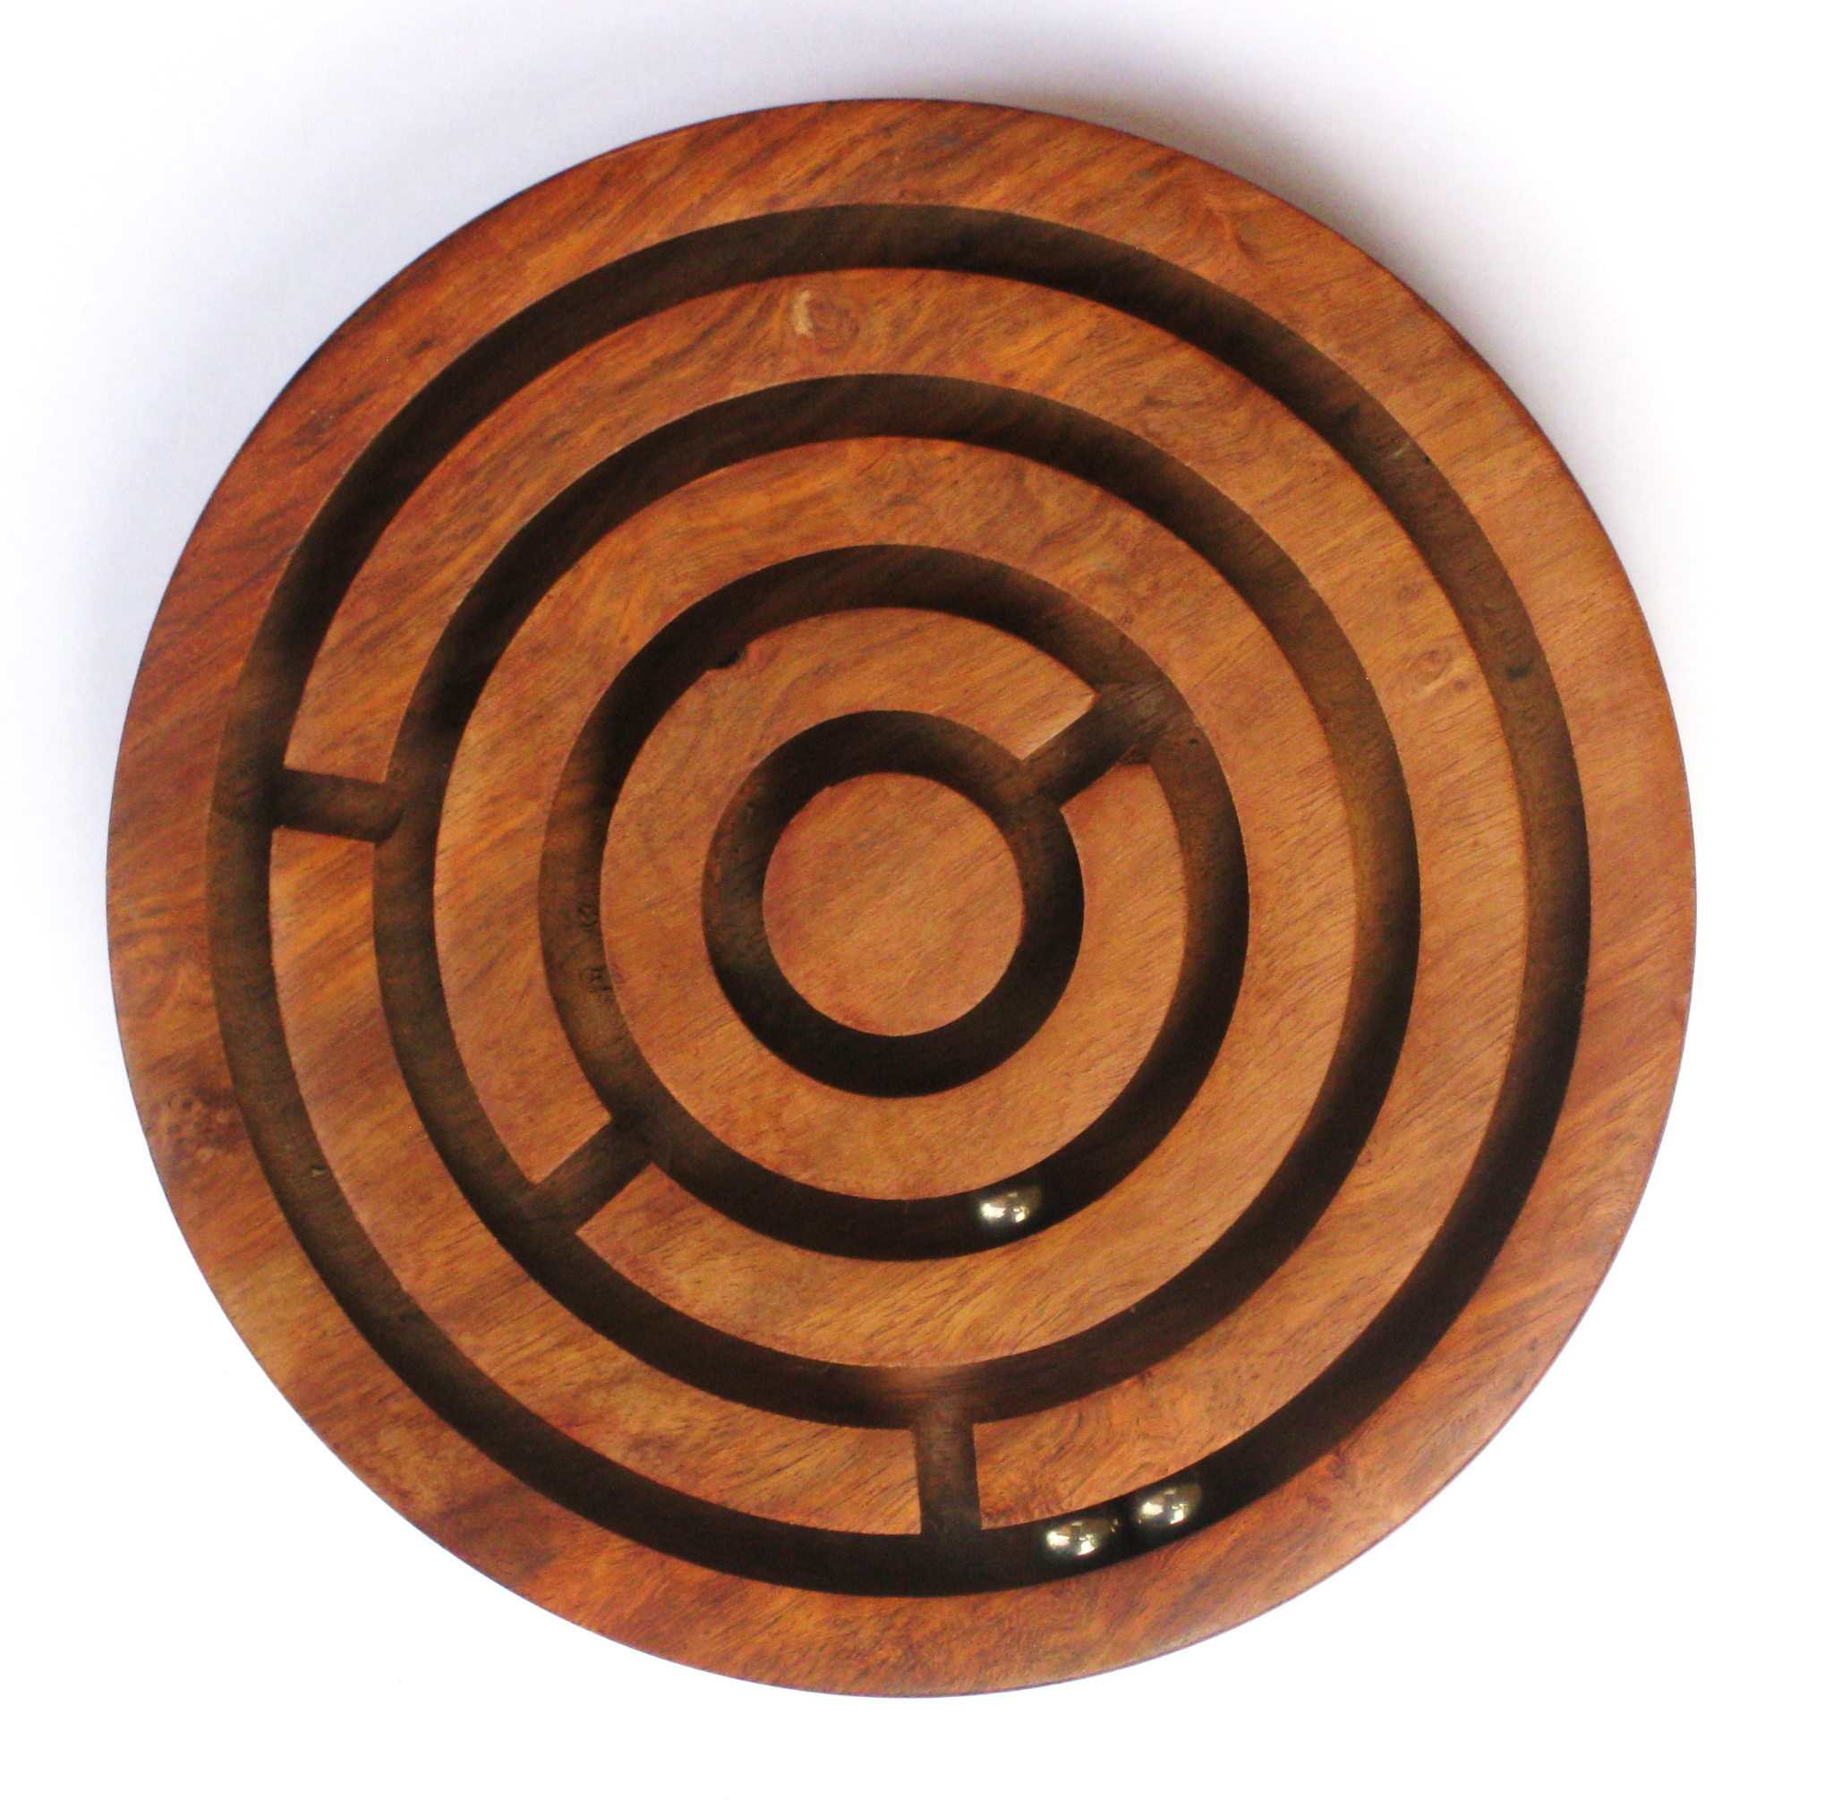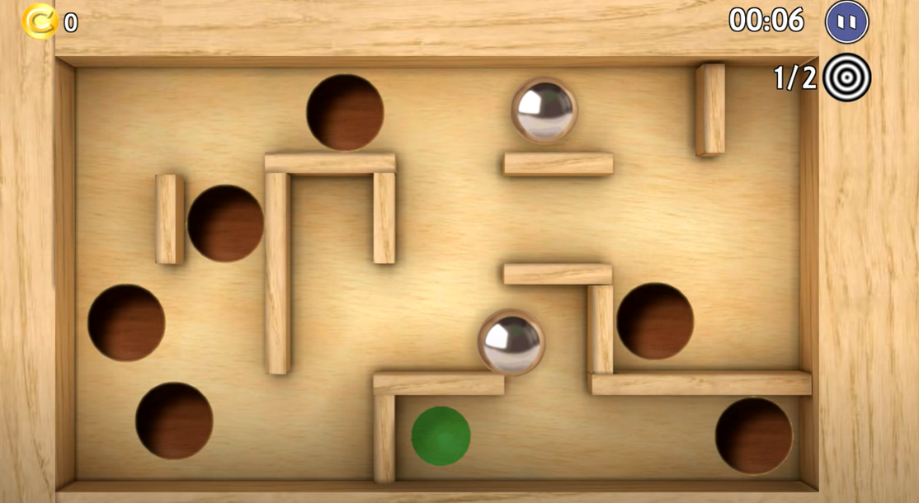

The battery took inspiration from resident evil fuses. They use fuses to turn on the elevator, lights and doors. For us, we took the referenced and used batteries instead as it is more common and recognizable than fuses.

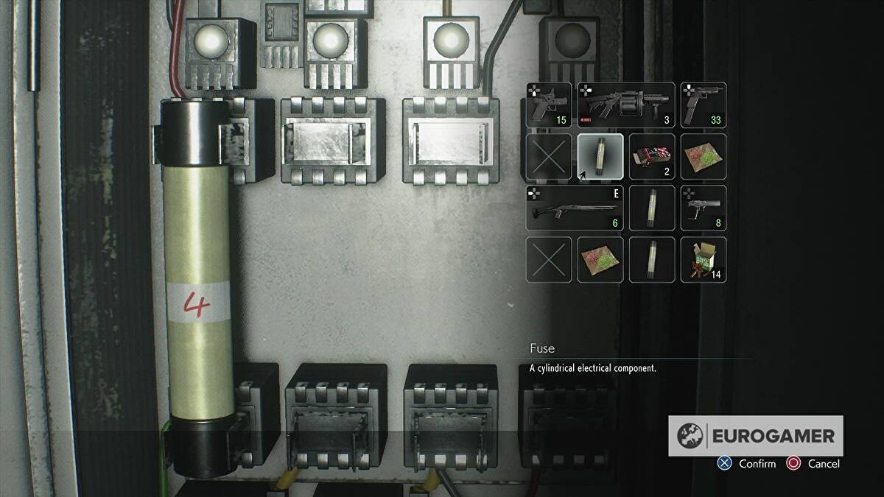

## Puzzle 2: Grid Puzzle

A grid is already presented in front of you as well as 5 clocks. A battery will spawn after the first puzzle. The player is to power the clocks with the battery.

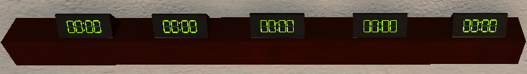

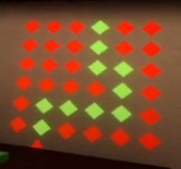

The grid puzzle consists of a grid along the wall. It is activated after the ball puzzle has been completed. The player will have to bring the battery obtained from the previous puzzle near a clock in the scene to activate it and solve the grid puzzle.

To solve this puzzle, the player will have to pick up the battery using the same grip button and place it in the power socket. This will turn the clocks on and the HUD would show “Plot a course by the hours, Count the steps every minute”. This is to tell the player which grid to interact with, using the help of the clocks. The clocks should show these numbers, ”12:01 3:04 12:05 9:02 12:01”. As the clock turns on, the hours digit will show the direction of which to travel while the minutes digit will show the number of steps the player should take in the stated direction.

## References

This took inspiration from the movie “Escape room” where in the scene the people trying to escape had to read clocks on a wall and step on the correct floor tiles accordingly or else something bad will happen.

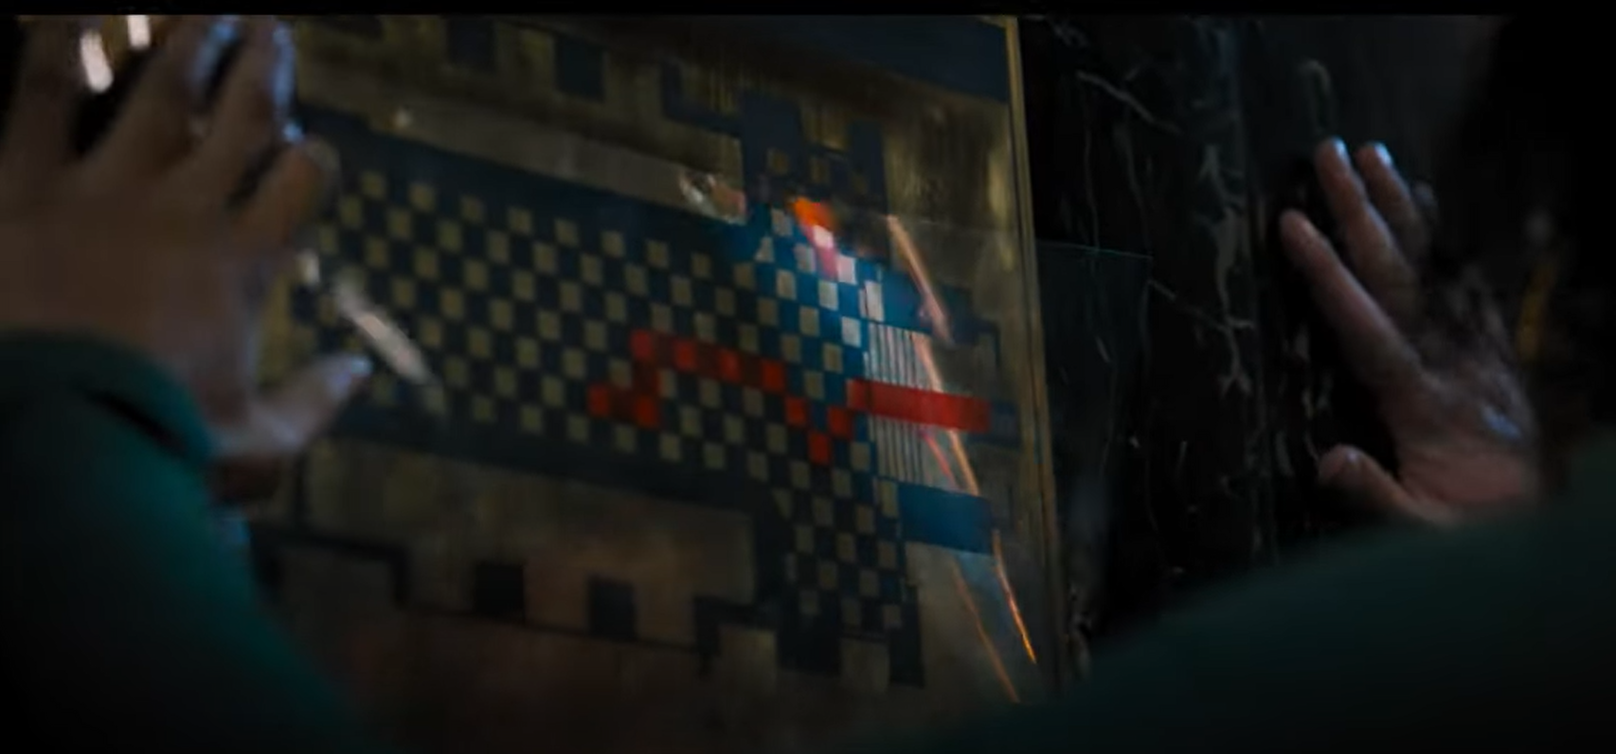

Incorporating this idea with the looks of nanoleaf lights, I created my own puzzle.

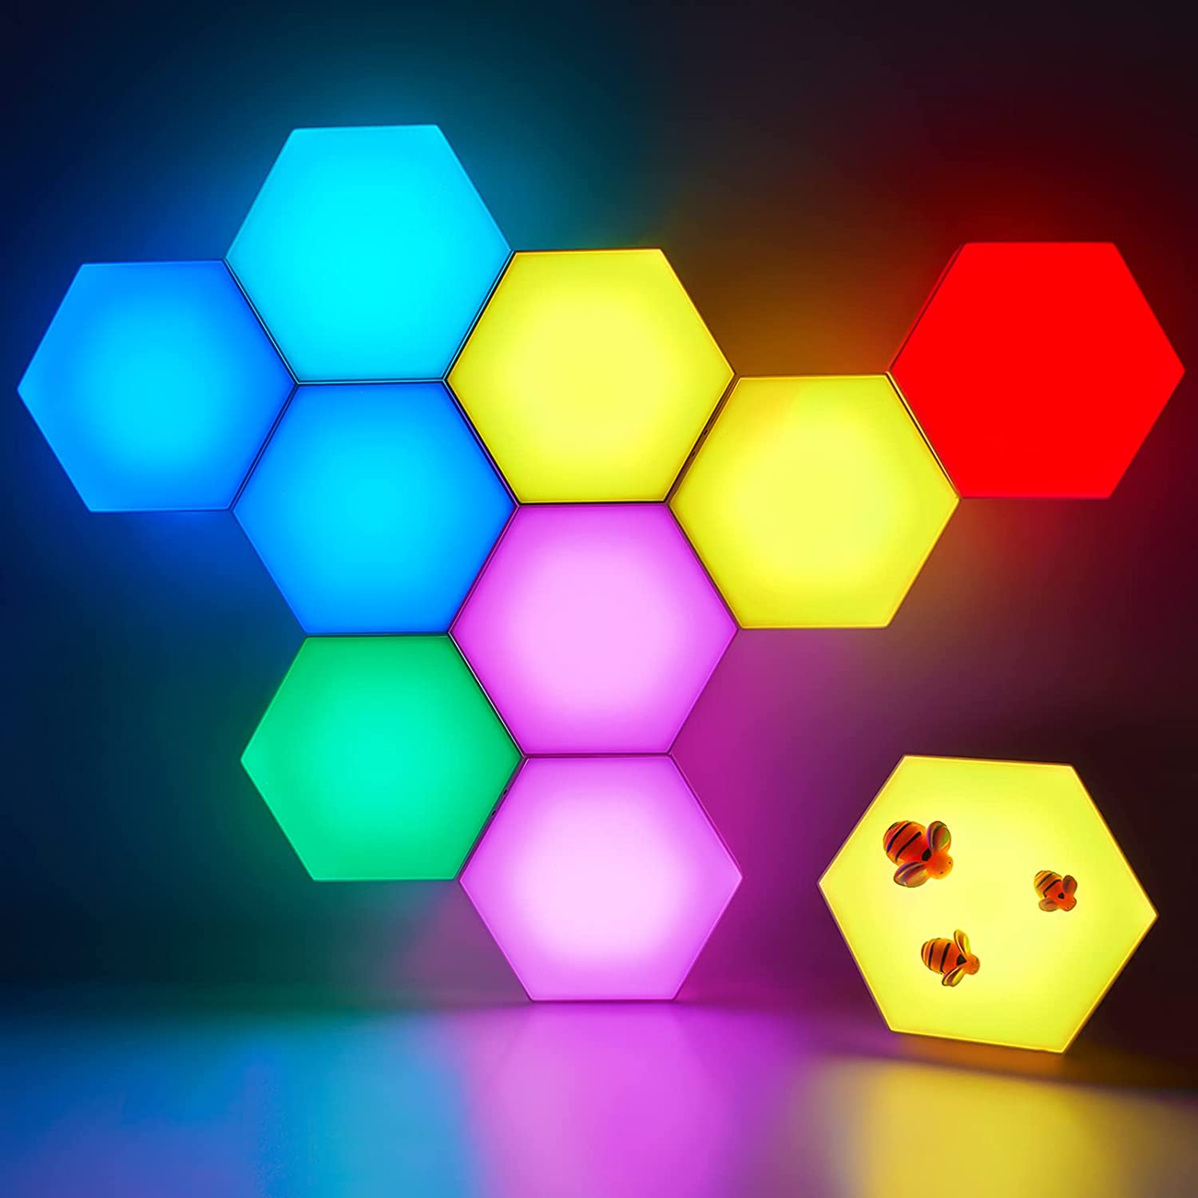

## Puzzle 3: Lock Puzzle

There is a cabinet and a lock. This puzzle is to unlock the lock with the thumb stick and grip button. After finishing the second puzzle the HUD text will switch to, “Temasek Polytechnic was founded in June 1974.”. Once the lock puzzle has been solved, the player will be able to pick up the key inside the box and use it to escape the room.

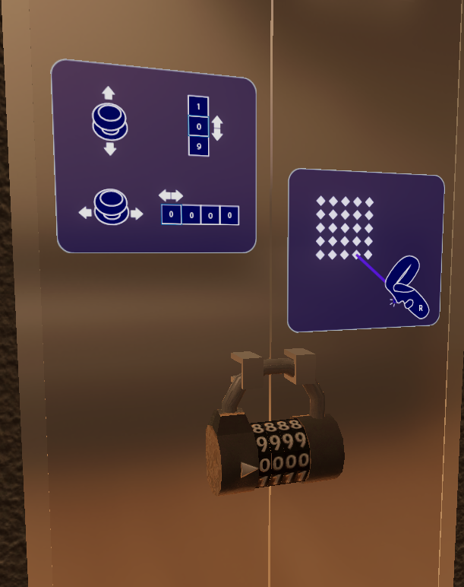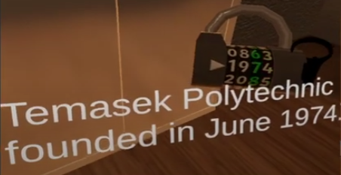

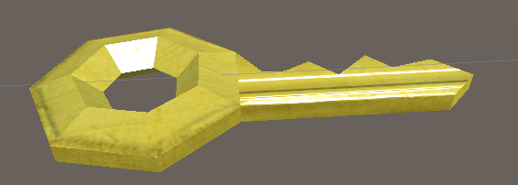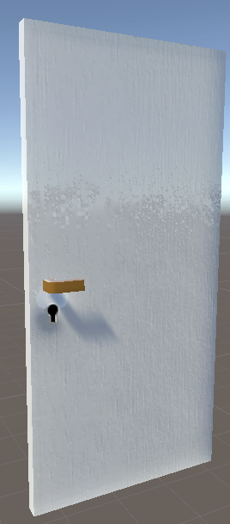

## References

## 

# Theme

## Art Style

The overall art style is Realistic. Bright and fantasy styled environment with real objects.

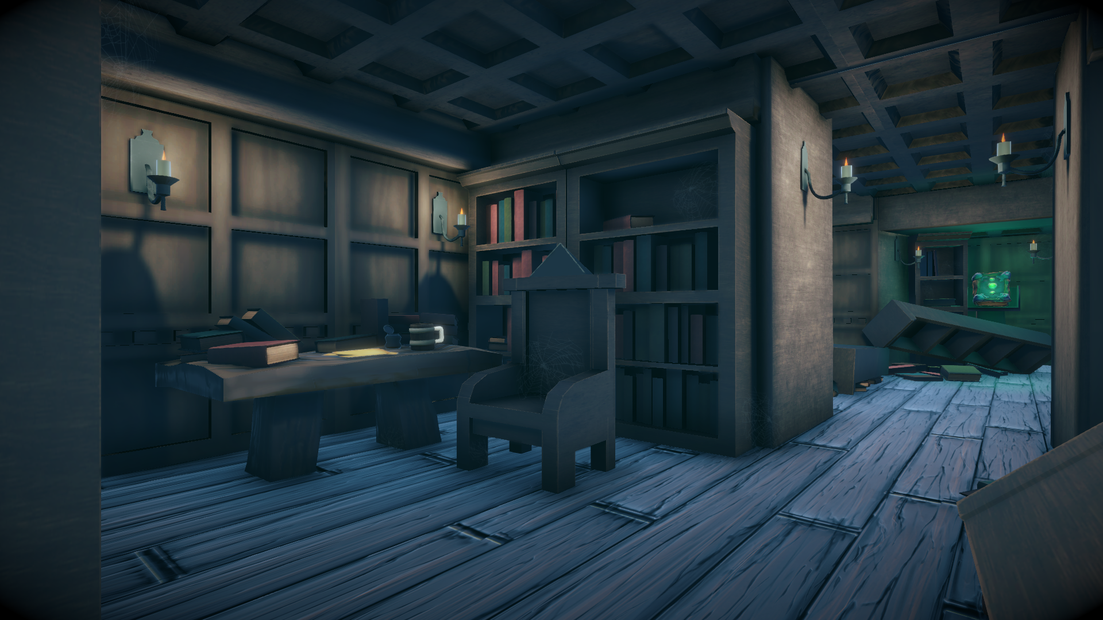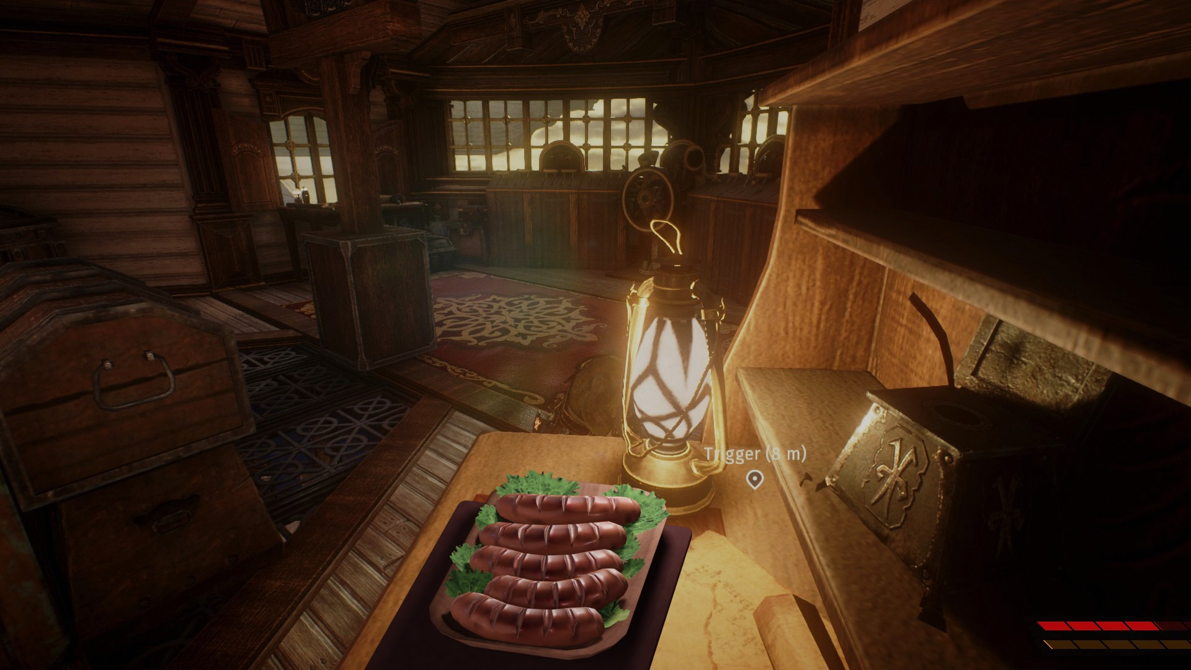

## Setting

The game takes place in an apartment during the night. There are typical objects you see in an apartment that the player has to tinker with to find the key and escape.

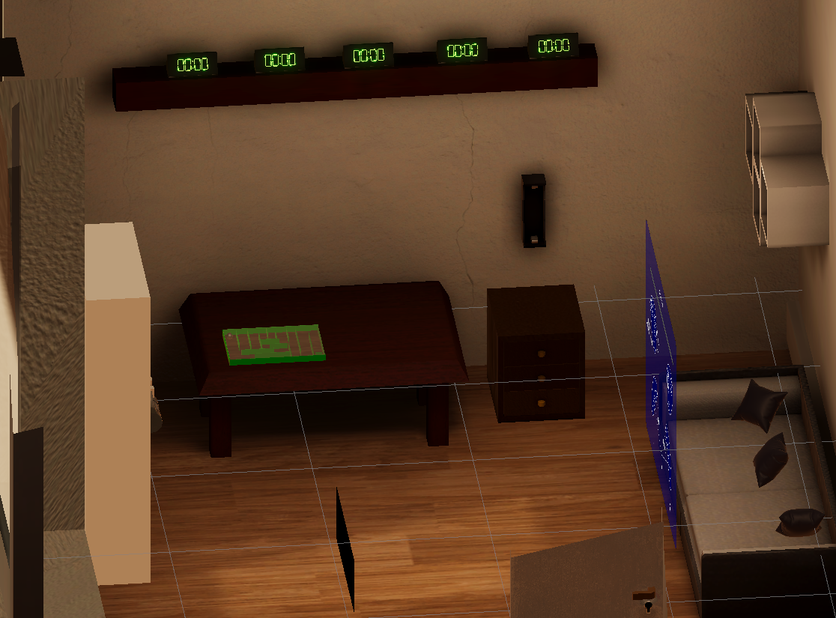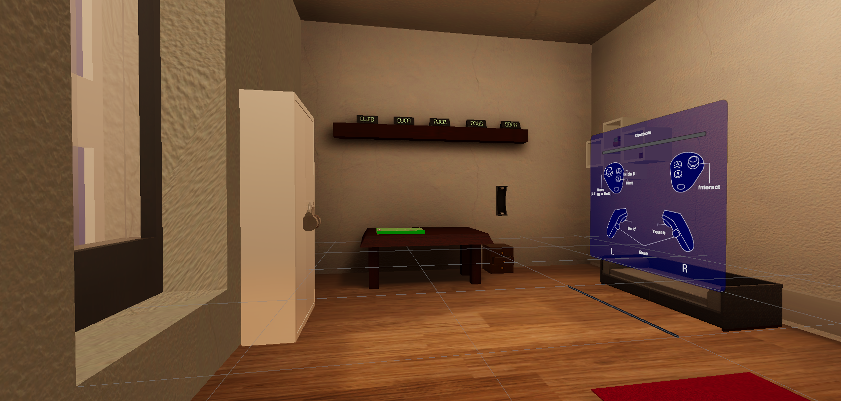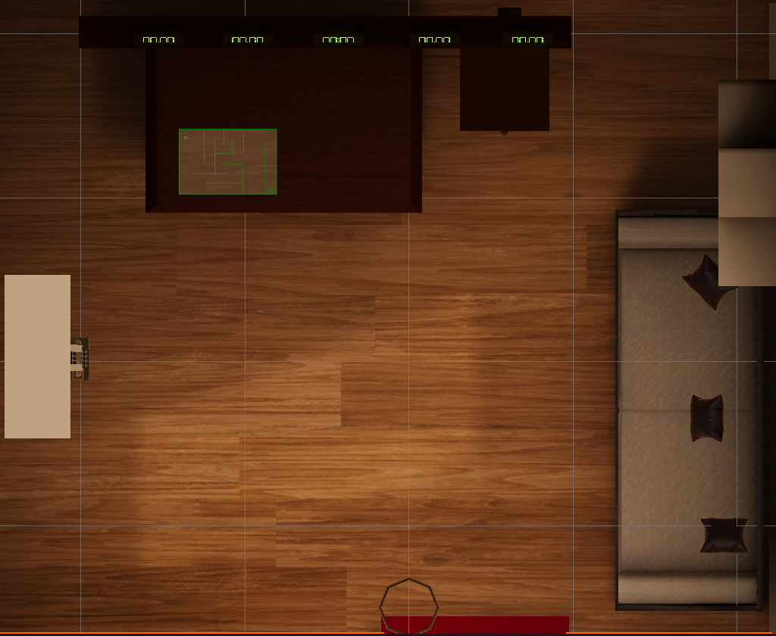

## Animation

Animations that can be found in the scene



## Lighting and Post Processing

Lighting is done by setting all environmental objects as static before baking the lighting. Baking the lighting achieves the main goal of game/frame rate optimisation while not compromising game aesthetics. The lighting is further enhanced with the use of light probes, wherein additional light processing can take place to enhance the accuracy of the projected light and shadows.

The post processing settings are as follows:

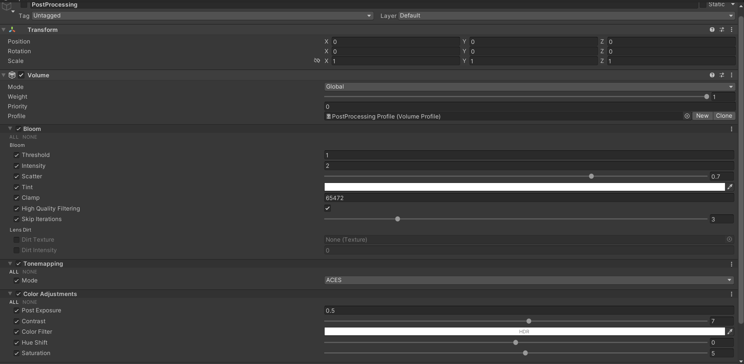

The light probe placements are as follows: (Note: In the screenshot, no post processing and lightmap baking has taken place)

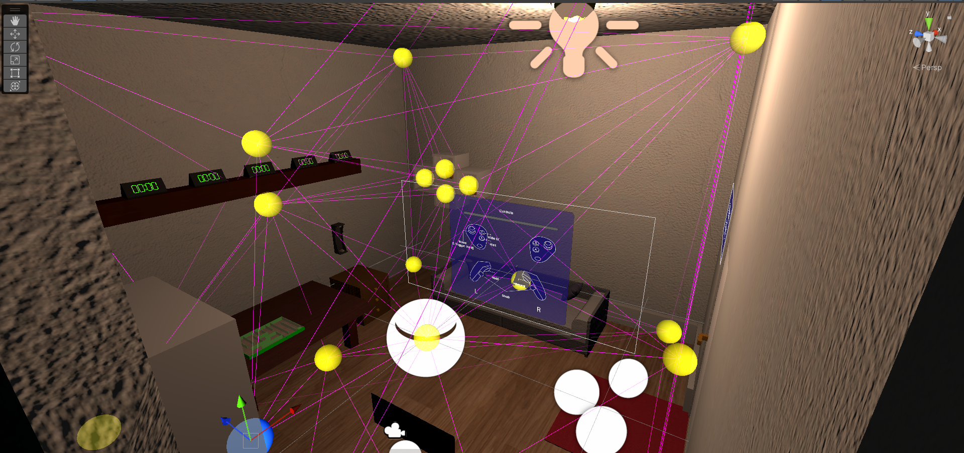

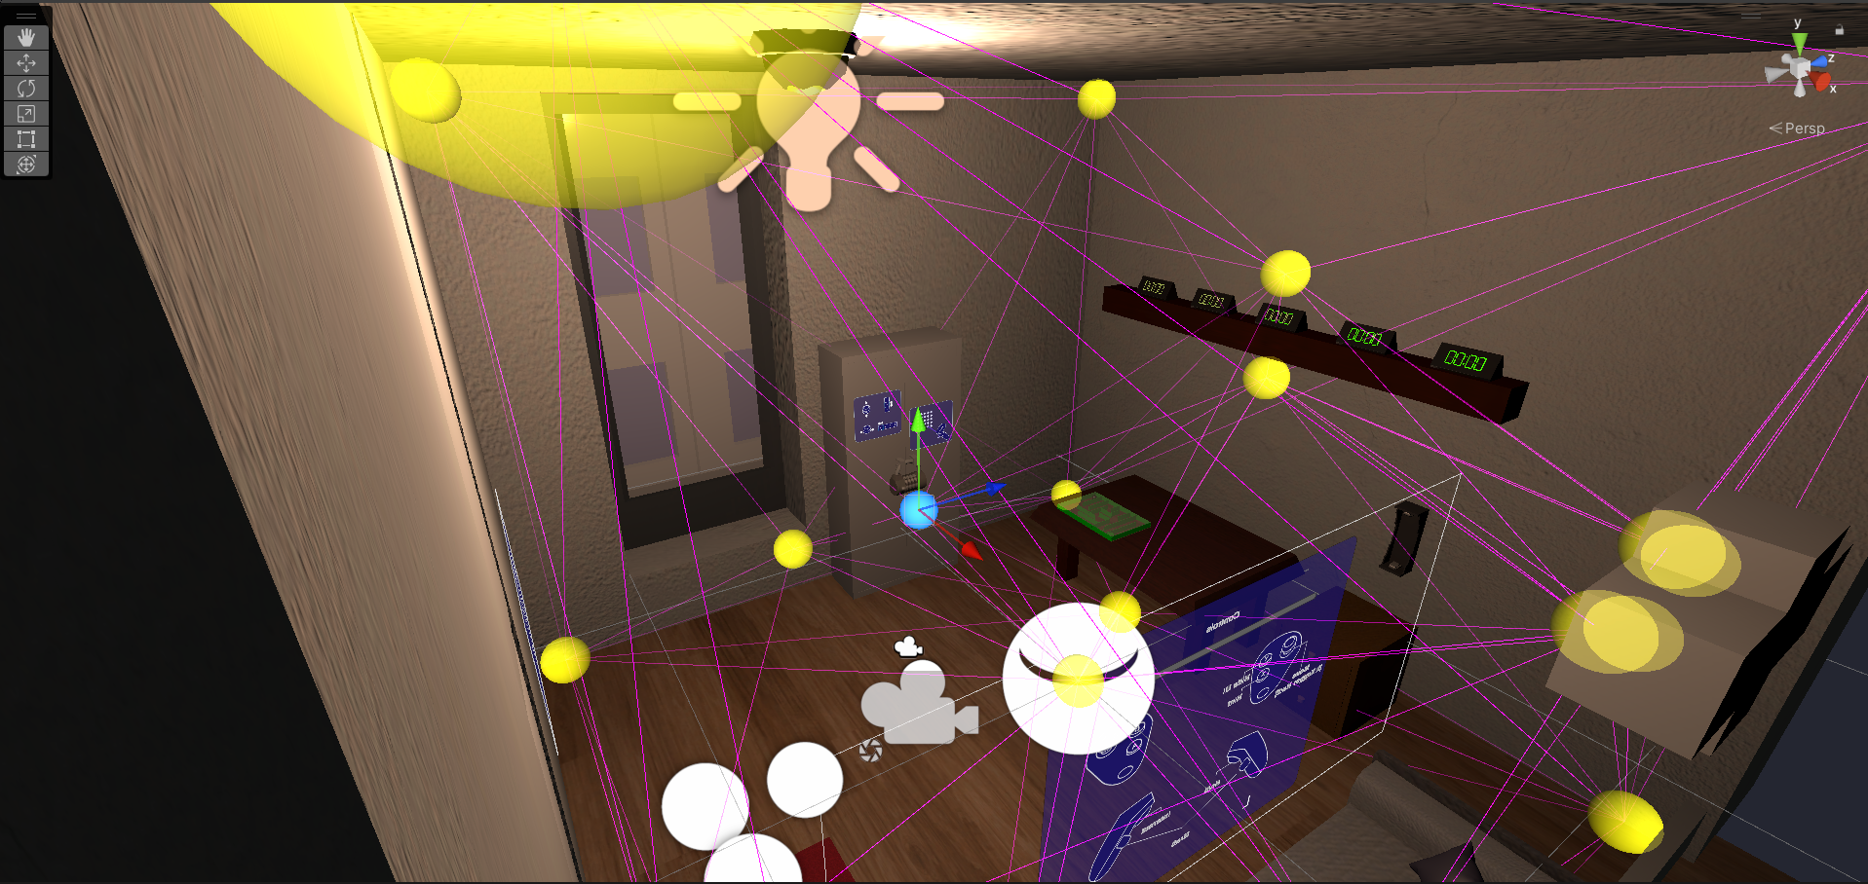

Screenshots of the differences in steps of light baking and processing are shown here:

NO BAKED LIGHTING, NO POST PROCESSING

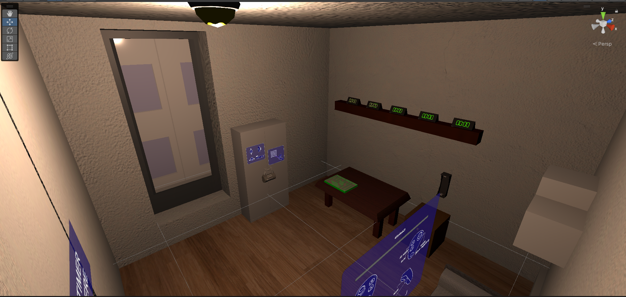

NO BAKED LIGHTING, POST PROCESSING ENABLED

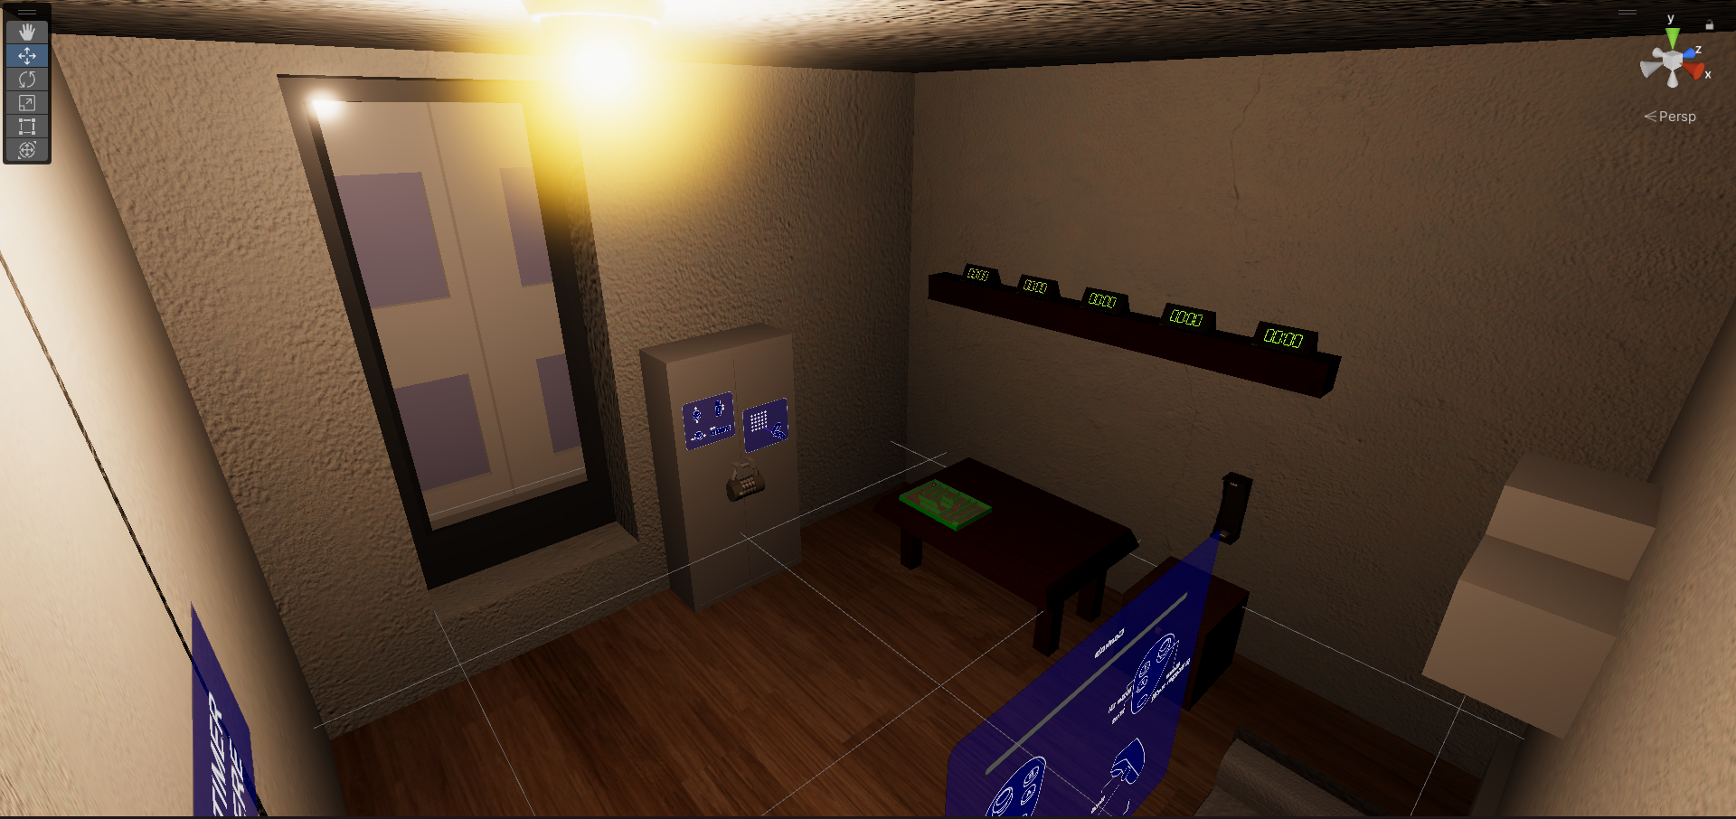

BAKED LIGHTING WITH POST PROCESSING

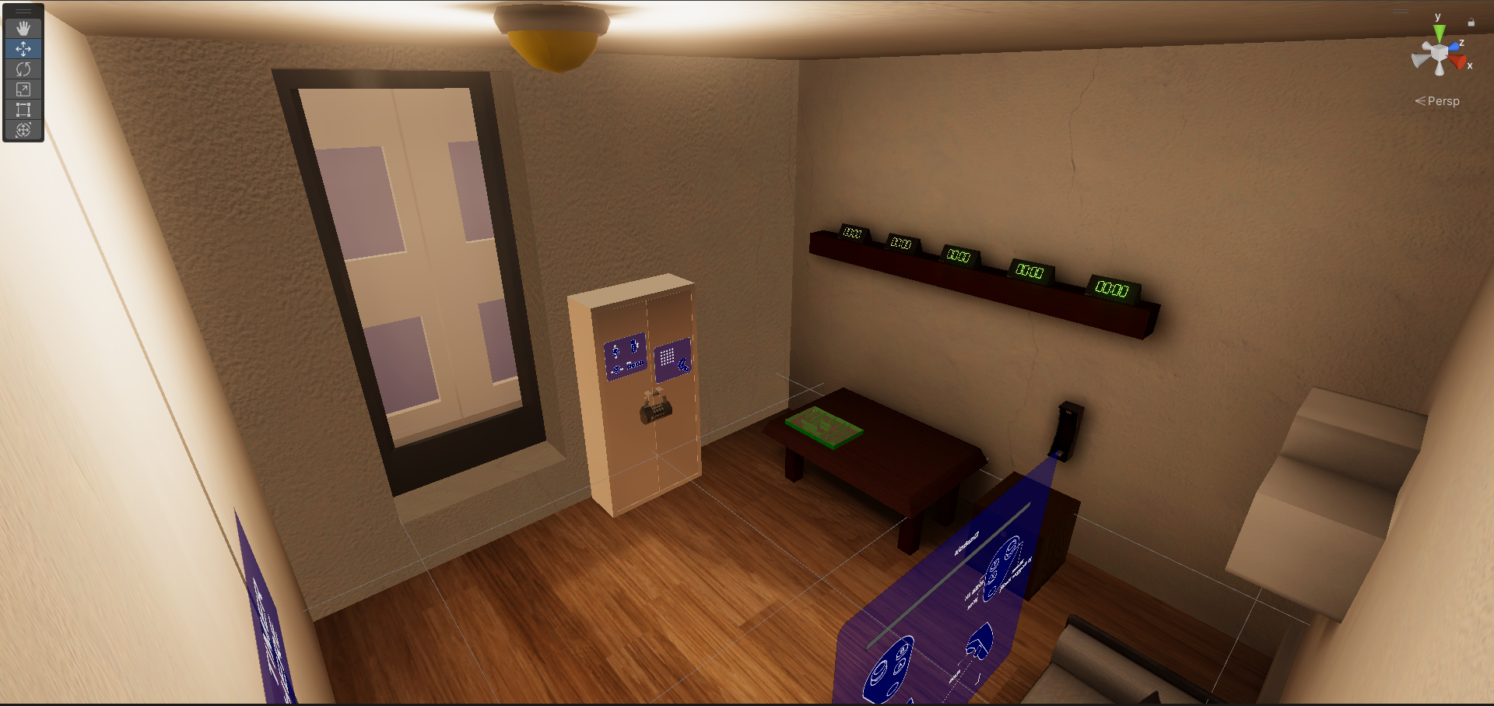

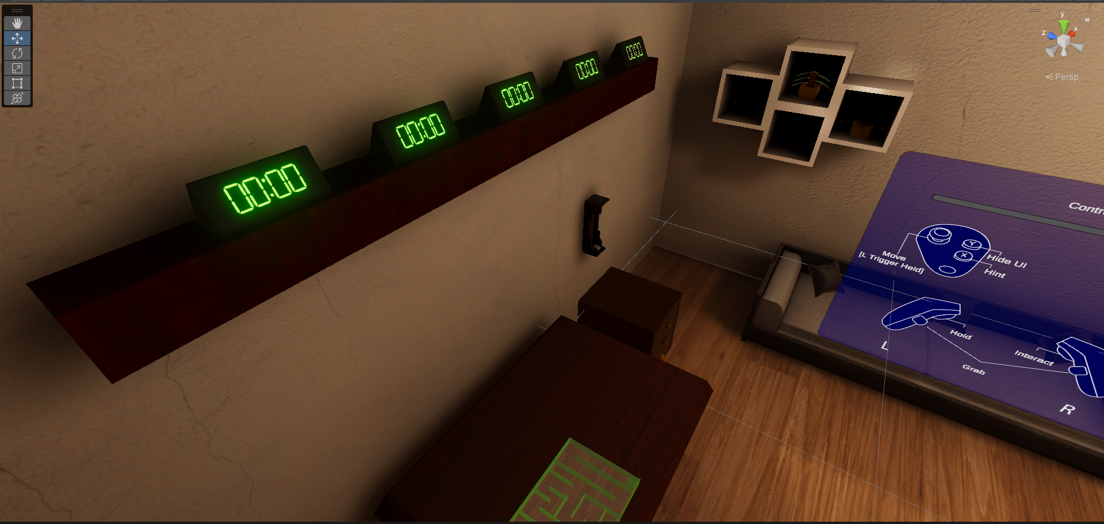

As can be seen from the screenshots, the lighting and shadows show a distinct progression in terms of quality which demonstrate the benefits of light probes, baked lighting and post processing which includes bloom effects for the lighting where emissive lighting objects appear to have a “glow”.

# Level Design







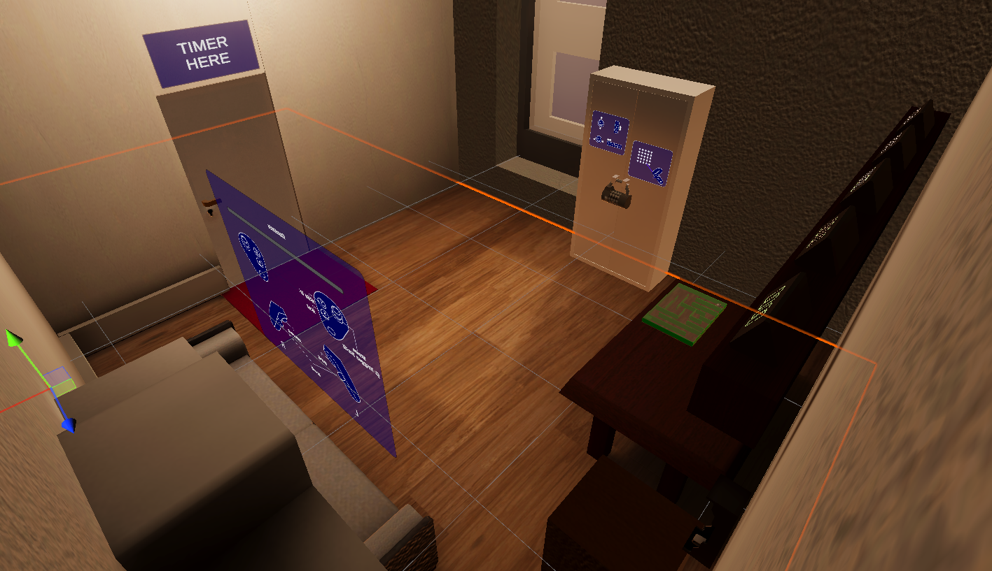

# Audio

| NAME | CATEGORY | DESCRIPTION |
| --- | --- | --- |
| BackgroundMusic | Background Music | Plays during game |

# MVP (Minimum Viable Product)

* Three puzzles for player to solve
* Built for the VR platform
* More Assets

# Wishlist

##### Added audio

* More rooms